**Project Description**

In order to support daily productivity, our project is a digital calendar software that includes task management and tailored recommendations. With an integrated to-do list for daily tasks and a daily routine tailored to each user's preferences and habits, this program will help users with their daily activities.

Professionals, students, and everyone else wishing to successfully manage their daily calendar and tasks are among the intended user base. The calendar application will exploit AI algorithms that study user behavior and preferences to provide highly customized recommendations for optimum productivity. Users can prioritize tasks at different levels so they can be alerted when important due dates are approaching. Moreover, the tool will be equipped with data visualizations that enable one to track progress while also helping identify areas where time is not well managed from.

**Requirements Summary**

|  |  |  |
| --- | --- | --- |
| **MINIMUM REQUIREMENTS** | Processor Cores | Dual Core |
| OS | Android: Version 7.0 or later  iOS: Version 12 or later |
| RAM | 2 GB |
| **RECOMMENDED REQUIREMENTS** | Processor Cores | Octa-core or higher |
| OS | Android: Version 10.0 or later  iOS: Version 14 or later |
| RAM | 4 GB |
| **OTHER REQUIREMENT** | Connectivity | Internet Access  Bluetooth (optional but recommended)  GPS |
| Permissions | Calendar, Contacts, Storage, Location, Notifications, Network Access, Background Data Usage, Task and Activity Recognition |

User Authentication: The system must support secure user authentication to protect personal data.

Personalized Recommendations: The application should use algorithms to provide personalized daily routines based on user input, habits, and preferences.

To-Do List Integration: Users must be able to create, update, and delete to-do lists, with tasks linked to specific dates and times.

User-Friendly Interface: The interface must be intuitive, allowing easy navigation and task management without a steep learning curve.

Notifications and Reminders: The system should send notifications and reminders for upcoming tasks and recommendations to ensure users stay on track.

Data Synchronization: The application should sync data across multiple devices, ensuring users have access to their schedules and tasks anywhere, anytime.

Customization Options: Users should be able to customize their calendar views (daily, weekly, monthly) and the appearance of the interface.

Analytics and Insights: Provide users with insights and analytics on their productivity patterns and task completion rates to help them improve over time.

**Prototype Description:**

The prototype for our digital calendar software, designed to support daily productivity, integrates task management with personalized recommendations. This application is intended for professionals, students, and anyone looking to effectively manage their daily schedules and tasks.

User Scenario:

Throughout the day, Raphael seamlessly uses his calendar app for scheduling and the "DAY’S" app for task management. he can prioritize tasks, maintain organization, and successfully manage her personal and professional lives thanks to the integration of the two.

**Login Page**

**Open Page**

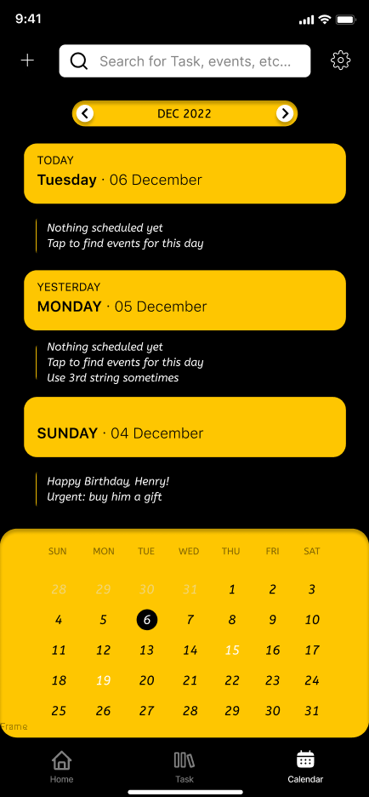

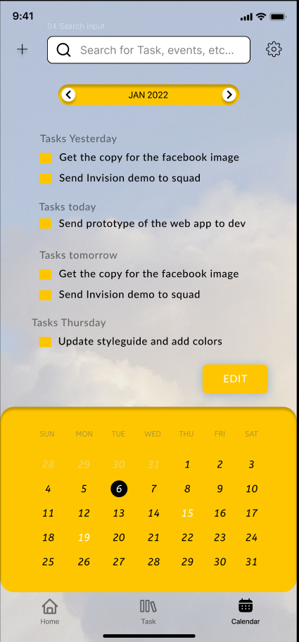

**Data Presentation**

**Home page**

**Rationale:**

The chosen prototype was selected to address the core needs identified in our project description: integrating a digital calendar with task management and personalized recommendations to enhance productivity for a diverse user base. This approach directly aligns with the requirements to create a user-friendly, highly functional, and customizable application that leverages AI to provide tailored productivity solutions.

**Initial Evaluation Plan:**

Finishing up the remaining goals on making the application usable has been the focus for the team. Upon finishing and implementing the changes the application will be sent for test runs and evaluation to the students and staff of Mapua Malayan Colleges of Mindanao for a test run.

**Usability Specifications:**

DAY'S is an all-inclusive personal assistant app that manages chores, routines, and productivity effectively to improve and simplify daily life. To assist users in maintaining focus and organization, it integrates a few features. Usability Specifications. The team aims for this prototype to achieve the following criteria for usability:

- User Interface Design:

Intuitive Navigation: Ensure the app features a straightforward, clear, and consistent navigation structure that users can easily understand.

Responsive Design: Guarantee smooth and immediate responses to user interactions.

Minimalist Aesthetic: Employ a minimalist design with a consistent visual language to avoid clutter and enhance focus on tasks and events.

- Accessibility:

Color Contrast: Utilize color schemes with good contrast that are comfortable for the eyes, catering especially to users with visual impairments.

Font Size and Readability: Ensure that font sizes are appropriate, and readability is maintained for all text elements, tailored for mobile use.

- Performance:

Fast Load Times: Optimize the app to load quickly and perform tasks efficiently, minimizing delays.

Resource Efficiency: Ensure the app consumes minimal battery, processing power, and data, preventing device slowdown and extending usability.

- User Feedback and Support:

Clear Error Messages: Provide informative and helpful error messages that explain what went wrong and how to fix it, using simple, non-technical language.

In-App Help Section: Include comprehensive tutorials, FAQs, and step-by-step guides to assist users in navigating and using the app’s features.

Feedback Mechanism: Allow users to easily provide feedback and report issues within the app, ensuring prompt attention to their concerns.

- Security:

Data Protection: Implement robust security measures such as encryption, secure authentication, and regular security audits to protect user data.

Privacy Control: Provide users with control over their privacy settings, including the ability to manage permissions for notifications, contacts, calendar access, and storage.

**Heuristic Evaluation:**

The evaluation of the calendar app will utilize Jakob Nielsen's 10 Usability Heuristics to ensure a comprehensive assessment of the app's usability and user experience.

**Visibility of System Status**

The calendar app will keep users informed about the current state and actions within the app through clear and timely feedback. Loading indicators, event confirmations, and notification badges will provide real-time updates on scheduling and task management activities.

**Match Between System and Real World**

The app will use familiar language and concepts that align with users' expectations and real-world scenarios. Terms like "Add Event," "Reminder," "Task List," and "Sync" are straightforward and reflect common scheduling activities, ensuring clarity and ease of use.

**User Control and Freedom**

The calendar app will offer users clearly marked options to undo actions or exit unwanted states without hassle. Features such as a "Cancel" button during event creation and an easily accessible logout option will enhance user control and freedom.

**Consistency and Standards**

Consistency will be maintained throughout the app to ensure that users do not have to guess whether different words, situations, or actions mean the same thing. The design, terminology, and layout will follow established conventions and branding guidelines.

**Error Prevention**

Preventive measures will be in place to minimize the occurrence of errors. For example, input validation for event dates and times and confirmation prompts before deleting events will help users avoid mistakes.

**Recognition Rather Than Recall**

The calendar app will make objects, actions, and options visible to reduce the reliance on memory. Key functions like event creation, task lists, and reminders will be easily accessible and prominently displayed.

**Flexibility and Efficiency of Use**

The app will cater to both novice and experienced users. Advanced users can benefit from shortcuts like quick event creation and voice input, while new users can follow guided tutorials and tips. This dual approach ensures efficiency for all user levels.

**Aesthetic and Minimalist Design**

The calendar app will feature a clean and minimalist design, displaying only relevant information. This approach avoids clutter and helps users focus on their tasks and schedules without distractions, enhancing overall usability.

**Help Users Recognize, Diagnose, and Recover from Errors**

Error messages within the app will be clear and constructive, avoiding technical jargon. These messages will explain the problem in plain language and suggest steps to correct it, helping users quickly recover from issues.

**Help and Documentation**

Users will have access to comprehensive help and documentation directly within the app. This includes searchable FAQs, step-by-step guides, and contact options for further assistance, ensuring users can easily find the information they need.

**Design Implications**

The calendar app prototype is generally successful according to the heuristic evaluation, but there are areas for improvement to enhance usability and user experience.

**Areas for Improvement:**

Error Prevention and Feedback:

Current Issue: Some areas lack proactive error prevention tools and explicit feedback.

Improvement: Introduce robust error detection and prevention mechanisms. Provide clear, user-friendly error messages and solutions.

Comprehensive Help and Documentation:

Current Issue: The app lacks comprehensive assistance and documentation.

Improvement: Develop a detailed help section with searchable FAQs, step-by-step guides, and tutorial videos.

Labeling and Iconography:

Current Issue: Labels and icons can be unclear, increasing cognitive load.

Improvement: Enhance labeling and icon clarity and consistency to make functions easily recognizable.

**Critique and Summary**

**Advantages**

**Comprehensive features:**

* User Authentication: Ensures secure access to personal data.
* Personalized Recommendations: AI-driven suggestions enhance user productivity by tailoring tasks and schedules.
* To-Do List Integration: Seamlessly combines scheduling and task management.
* User-Friendly Interface: Intuitive design minimizes the learning curve and improves user adoption.
* Notifications and Reminders: Keeps users on track with timely alerts.
* Data Synchronization: Provides consistency across multiple devices.
* Customization Options: Allows users to personalize their experience, improving satisfaction.
* Analytics and Insights: Helps users track and improve productivity through detailed data.

**Enhanced User Experience:**

* The integration of AI and data visualizations creates a dynamic and responsive tool that evolves with the user's habits and needs.
* Customization and intuitive navigation cater to a wide audience, from professionals to students.

**Disadvantages**

**Complexity of AI Implementation:**

* Developing and fine-tuning AI algorithms for personalized recommendations may require significant resources and expertise.

**User Interface Design:**

* Creating an intuitive yet comprehensive interface that includes all desired features without overwhelming the user requires careful design and usability testing.

**Device Compatibility:**

* Ensuring seamless synchronization and consistent performance across various devices and operating systems can be technically demanding.

**Changes to the requirements**

* During the development of our prototype, we did not alter any of our initial requirements or usability criteria. Our comprehensive planning ensured that the original specifications—secure user authentication, AI-driven personalized recommendations, seamless to-do list integration, an intuitive interface, notifications and reminders, data synchronization, customization options, and productivity analytics—adequately addressed the needs of our user base and project goals. The robustness of our design and clarity of our objectives meant that our prototype met all outlined criteria without the need for adjustments, ensuring a consistent and effective development process.

**Summary of the Project**

DAY'S is an advanced productivity application designed to streamline daily tasks and schedules for professionals, students, and anyone seeking efficient time management. This digital assistant seamlessly integrates task management, personalized recommendations, and intuitive design to enhance productivity and organization. With key features such as effortlessly create, update, and prioritize tasks with integrated to-do lists and reminders. AI-driven suggestions tailor daily routines based on user preferences and habits. Easily schedule events, set reminders, and sync data across multiple devices for seamless access. Intuitive design minimizes learning curves and ensures a smooth user experience. Timely alerts keep users on track with upcoming tasks and events. Track productivity patterns and progress with insightful analytics and reports.

To enhance DAY'S, ongoing evaluations and design iterations are essential. Continuous feedback loops, comprehensive user testing, and real-world scenario simulations will refine the app's functionality and user experience. Future developments may include Integrate financial management tools for budgeting and spending analysis. Provide insights into future spending trends and financial habits. Conduct long-term usability studies and real-world testing to optimize user interactions. Ensure seamless performance across various devices and platforms. Enhance accessibility features for users with diverse needs.

Through strategic funding, advanced prototype tools, skilled usability consultants, and ongoing user feedback, DAY'S aims to deliver a highly efficient and user-centric productivity solution that caters to the diverse needs of its users. DAY'S is dedicated to providing an unparalleled productivity experience, empowering users to manage their tasks, schedules, and finances effectively. With continuous improvements and user-centric enhancements, DAY'S strives to be the go-to productivity app for individuals looking to optimize their daily routines and achieve their goals efficiently.